MIPS SINGLE CYCLE SIMULATOR

Languages used: HTML, CSS, JavaScript, SVG

JavaScript is used to create functions which shows the output of different MIPS instructions. Different functions show their respective path of the instruction and the output from Control along with the data values from the instructions.

Scalable vector graphics are used to visualize the diagram with different colors. Every JS function is linked with particular SVG objects. As the function runs, the respective SVG objects changes according to the instruction.

There are 2 tabs on the webpage. HOME and INSTRUCTIONS.

HOME: The Simulator is coded on this tab. There is a text box for instructions, a dynamic diagram which alters for different instructions, a steps table, a register table, a memory table and a trace table. All these tables are hidden. After clicking the Simulate button, these tables will appear with the instructions and data in it.

The steps table contains the instructions. A single instruction can be selected at a time. After selecting an instruction, the diagram will alter according to the instruction.

The register table contains the values stored in registers after completing the whole program. The memory table contains the memory blocks. The trace table contains the states of the Control signals.

Example: The instrution ‘addi’ is linked to the Control signals Immidiate, ALUOp and RegWrite. So as the function runs, these lines will be triggered and change color to red. The instructions will also show the data flowing through the lines from and to registers.

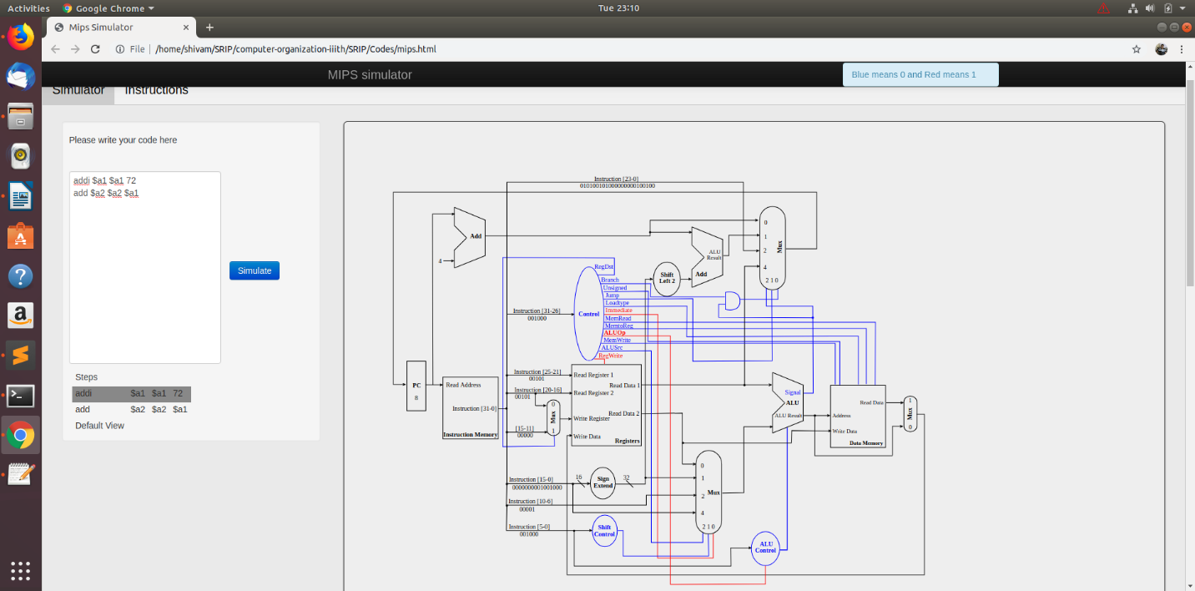

By clicking on different steps on the left pane, the diagram gets updated. It shows the data path of that particular instruction.

INSTRUCTIONS: It contains the instrucion format and notes for using the simulator. A table containing all the supported MIPS instructions is present.

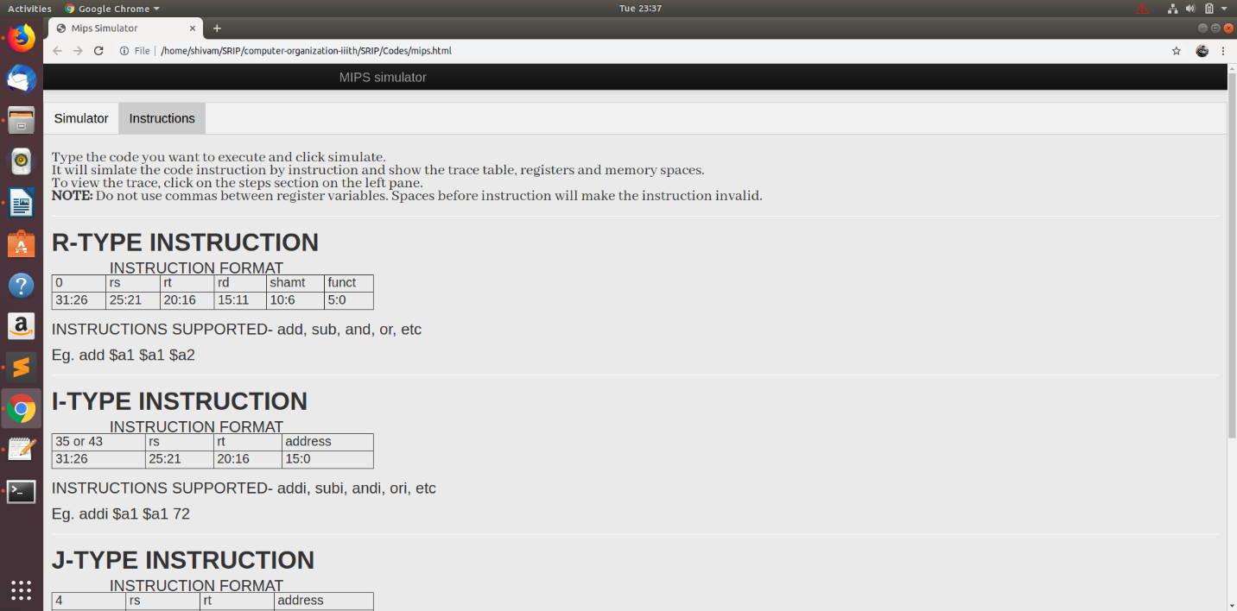

**Test Cases:**

|  |  |  |  |  |  |  |  |  |  |  |
| --- | --- | --- | --- | --- | --- | --- | --- | --- | --- | --- |
| **Test Scenario ID** | | Code simulation | | | **Test Case ID** | | | 1 | | |
| **Test Case Description** | | Code simulation – positive case | | | **Test Priority** | | | high | | |
| Test Execution Steps: | | | | | | | | | | | |
| **S.No** | **Action** | | **Inputs** | **Expected Output** | | **Actual Output** | **Test Browser** | | **Test Result** | **Test Comments** | |
| 1 | Launch | | Open mips.html | MIPS Simulator | | MIPS Simulator | Mozilla Firefox - 67.0 | | Pass | Web page launched | |
| 2 | Type code in text box | | addi $a1 $a1 72 | Visible code input in text box | | Visible code input in text box | Mozilla Firefox – 67.0 | | Pass | Code visible in text box | |
| 3 | Simulate | | Click simulate | Register, memory, steps and trace table appear | | Register, memory, steps and trace table appear | Mozilla Firefox – 67.0 | | Pass | Output visible | |
| 4 | Select step | | Click on step | Alterations in diagram | | Alterations in diagram | Mozilla Firefox – 67.0 | | Pass | Diagram altered | |

|  |  |  |  |  |  |  |  |  |  |  |
| --- | --- | --- | --- | --- | --- | --- | --- | --- | --- | --- |
| **Test Scenario ID** | | Code simulation | | | **Test Case ID** | | | 2 | | |
| **Test Case Description** | | Code simulation multiple lines – positive case | | | **Test Priority** | | | high | | |
| Test Execution Steps: | | | | | | | | | | | |
| **S.No** | **Action** | | **Inputs** | **Expected Output** | | **Actual Output** | **Test Browser** | | **Test Result** | **Test Comments** | |
| 1 | Launch | | Open mips.html | MIPS Simulator | | MIPS Simulator | Mozilla Firefox - 67.0 | | Pass | Web page launched | |
| 2 | Type code in text box | | addi $a1 $a1 72  add $a2 $a2 $a1 | Visible code input in text box | | Visible code input in text box | Mozilla Firefox – 67.0 | | Pass | Code visible in text box | |
| 3 | Simulate | | Click simulate | Register, memory, steps and trace table appear | | Register, memory, steps and trace table appear | Mozilla Firefox – 67.0 | | Pass | Output visible | |
| 4 | Select 1st step | | Click on 1st step | Alterations in diagram | | Alterations in diagram | Mozilla Firefox – 67.0 | | Pass | Diagram altered | |
| 5 | Select 2nd step | | Click on 2nd step | Alterations in diagram | | Alterations in diagram | Mozilla Firefox – 67.0 | | Pass | Diagram altered | |

|  |  |  |  |  |  |  |  |  |  |  |
| --- | --- | --- | --- | --- | --- | --- | --- | --- | --- | --- |
| **Test Scenario ID** | | Code simulation | | | **Test Case ID** | | | 3 | | |
| **Test Case Description** | | Code simulation – negative case | | | **Test Priority** | | | medium | | |
| Test Execution Steps: | | | | | | | | | | | |
| **S.No** | **Action** | | **Inputs** | **Expected Output** | | **Actual Output** | **Test Browser** | | **Test Result** | **Test Comments** | |
| 1 | Launch | | Open mips.html | MIPS Simulator | | MIPS Simulator | Mozilla Firefox - 67.0 | | Pass | Web page launched | |
| 2 | Type code in text box | | add $a1 $a1 72 | Visible code input in text box | | Visible code input in text box | Mozilla Firefox – 67.0 | | Pass | Code visible in text box | |
| 3 | Simulate | | Click simulate | Register, memory, steps and trace table appear without any changes in values | | Register, memory, steps and trace table appear without any changes in values | Mozilla Firefox – 67.0 | | Pass | Instruction not simulated and table values not updated | |

|  |  |  |  |  |  |  |  |  |  |  |
| --- | --- | --- | --- | --- | --- | --- | --- | --- | --- | --- |
| **Test Scenario ID** | | Code simulation | | | **Test Case ID** | | | 4 | | |
| **Test Case Description** | | Code simulation – comma separated values negative case | | | **Test Priority** | | | medium | | |
| Test Execution Steps: | | | | | | | | | | | |
| **S.No** | **Action** | | **Inputs** | **Expected Output** | | **Actual Output** | **Test Browser** | | **Test Result** | **Test Comments** | |
| 1 | Launch | | Open mips.html | MIPS Simulator | | MIPS Simulator | Mozilla Firefox - 67.0 | | Pass | Web page launched | |
| 2 | Type code in text box and separate the registers with comma | | addi $a1,$a1,72 | Visible code input in text box | | Visible code input in text box | Mozilla Firefox – 67.0 | | Pass | Code visible in text box | |
| 3 | Simulate | | Click simulate | Register, memory, steps and trace table appear without any changes in values | | Register, memory, steps and trace table appear without any changes in values | Mozilla Firefox – 67.0 | | Pass | Instruction not simulated and table values not updated | |

|  |  |  |  |  |  |  |  |  |  |  |
| --- | --- | --- | --- | --- | --- | --- | --- | --- | --- | --- |
| **Test Scenario ID** | | Code simulation | | | **Test Case ID** | | | 5 | | |
| **Test Case Description** | | Code simulation – space before instruction negative case | | | **Test Priority** | | | Medium | | |
| Test Execution Steps: | | | | | | | | | | | |
| **S.No** | **Action** | | **Inputs** | **Expected Output** | | **Actual Output** | **Test Browser** | | **Test Result** | **Test Comments** | |
| 1 | Launch | | Open mips.html | MIPS Simulator | | MIPS Simulator | Mozilla Firefox - 67.0 | | Pass | Web page launched | |
| 2 | Type code in text box  And give space before it | | addi $a1 $a1 72 | Visible code input in text box | | Visible code input in text box | Mozilla Firefox – 67.0 | | Pass | Code visible in text box | |
| 3 | Simulate | | Click simulate | JS Alert appears | | JS Alert appears | Mozilla Firefox – 67.0 | | Pass | Output visible | |

|  |  |  |  |  |  |  |  |  |  |  |
| --- | --- | --- | --- | --- | --- | --- | --- | --- | --- | --- |
| **Test Scenario ID** | | Code simulation | | | **Test Case ID** | | | 6 | | |
| **Test Case Description** | | Out of bounds value | | | **Test Priority** | | | Medium | | |
| Test Execution Steps: | | | | | | | | | | | |
| **S.No** | **Action** | | **Inputs** | **Expected Output** | | **Actual Output** | **Test Browser** | | **Test Result** | **Test Comments** | |
| 1 | Launch | | Open mips.html | MIPS Simulator | | MIPS Simulator | Mozilla Firefox - 67.0 | | Pass | Web page launched | |
| 2 | Type code in text box | | addi $a1 $a1 65537 | Visible code input in text box | | Visible code input in text box | Mozilla Firefox – 67.0 | | Pass | Code visible in text box | |
| 3 | Simulate | | Click simulate | 65537 mod 65536 (i.e 2^16) | | 65537 mod 65536 (i.e 2^16) | Mozilla Firefox – 67.0 | | Pass | Overflown output visible | |